The Vine’s Cycle: The Art of Vineyard Work Through the Seasons

Welcome to the fascinating world of viticulture, where each season reveals unique skills and a daily commitment to the quality of our grapes and wines. Discover, month by month, the key stages of work in the vineyards at Château Lastours!

Winter – The Awakening of the Winemaker

January – March: Pruning  
Winter marks the start of the new wine growing season! From January, our teams begin pruning the vines — a demanding task that shapes the future harvest and ensures the longevity of our vineyard. Pruning involves selecting and limiting the number of buds on each vine to balance vigor and quality. Here, the winemaker’s know-how makes all the difference: every cut is a calculated decision for the next vintage.

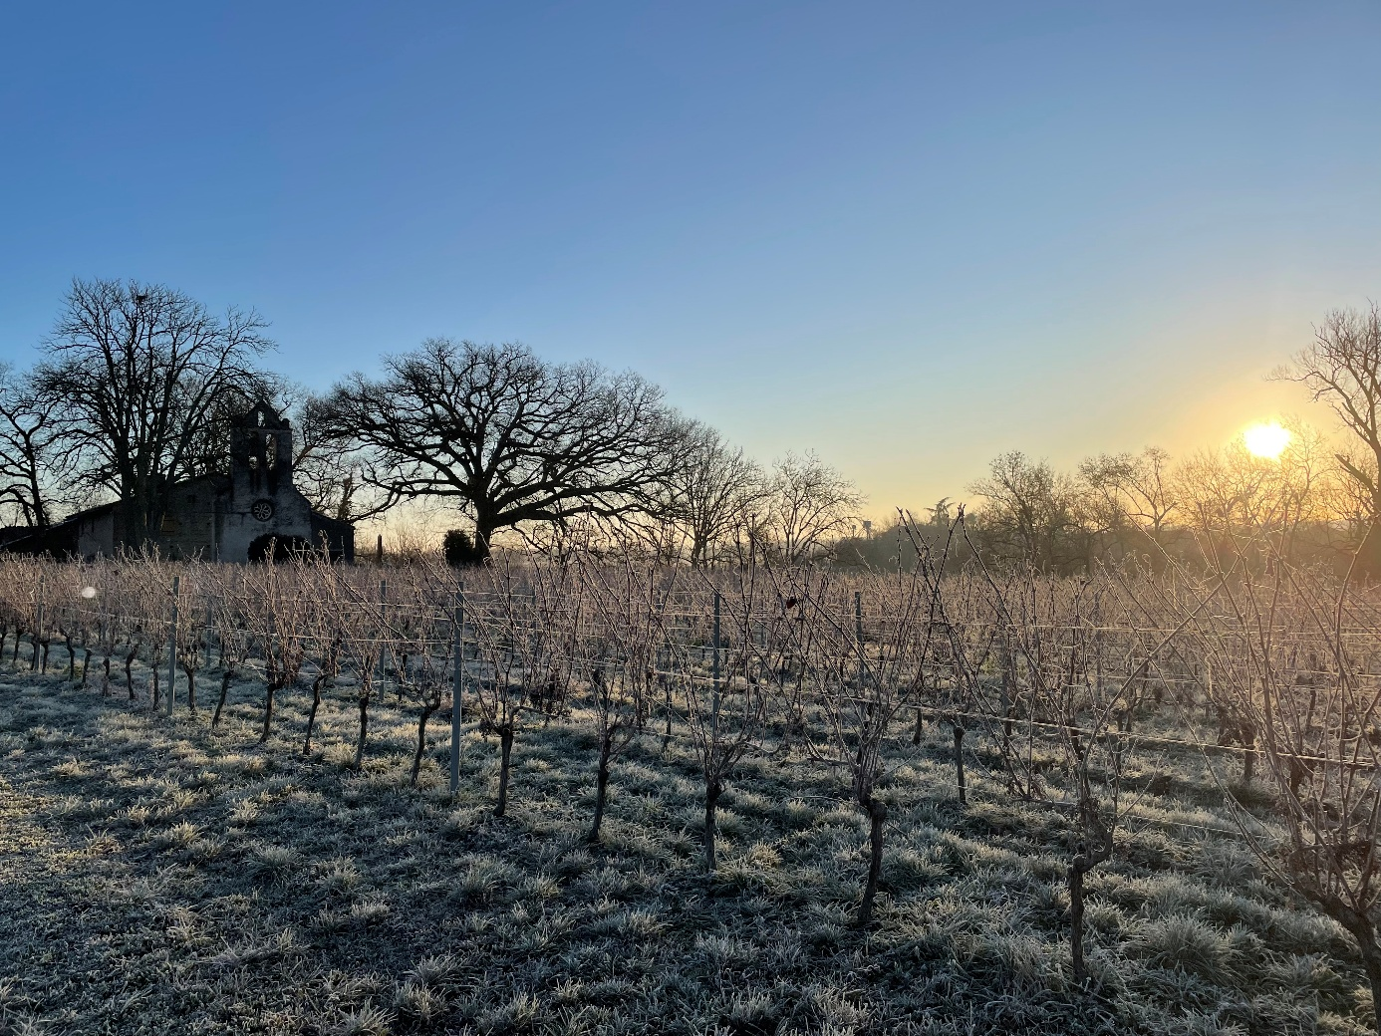

Spring – Life Returns

Late February – March: The Weeping  
The vine’s awakening is marked by the rise of sap: the “weeping.” The first droplets appear on the freshly cut canes, heralding a new cycle of life.

April – May: Debudding and Soil Work  
Buds swell and burst, covering the vines in vibrant green. This is the time for debudding: selecting the best shoots for concentrated grape clusters and optimal ripening. At the same time, we care for our soils — mechanical tilling, managing ground cover — nothing is left to chance to preserve the vitality of our terroir.

Summer – The Quest for Maturity

June: Flowering & Vine Protection  
Flowering is the delicate ballet of pollination, when each cluster can produce up to 200 tiny flowers! At this stage, the vine is fragile: we take great care to protect it, adopting eco-friendly practices, favoring biocontrol methods, and maintaining close observation of the vineyard.

Late June – July: Trellising and Veraison  
Next comes trellising — guiding the vine’s growth to maximize its exposure to the sun — followed by leaf trimming to refine the canopy so sunlight can bathe the grapes. In July, the magic happens! The process culiminates with veraison: the berries change from fresh jade green to velvety purple, a promise of the harvest to come.

Late Summer – Awaiting Perfection

July – September: Ripening and Quality Control

The grapes gain in sugars, their aromas develop, and acidity finds its balance. Day after day, we monitor the evolution of the vineyard — tasting, analyzing, and observing each berry — aiming for the perfect equilibrium. The choice of harvest date is never left to chance: it is about capturing the exact moment when our terroir’s identity is fully expressed.

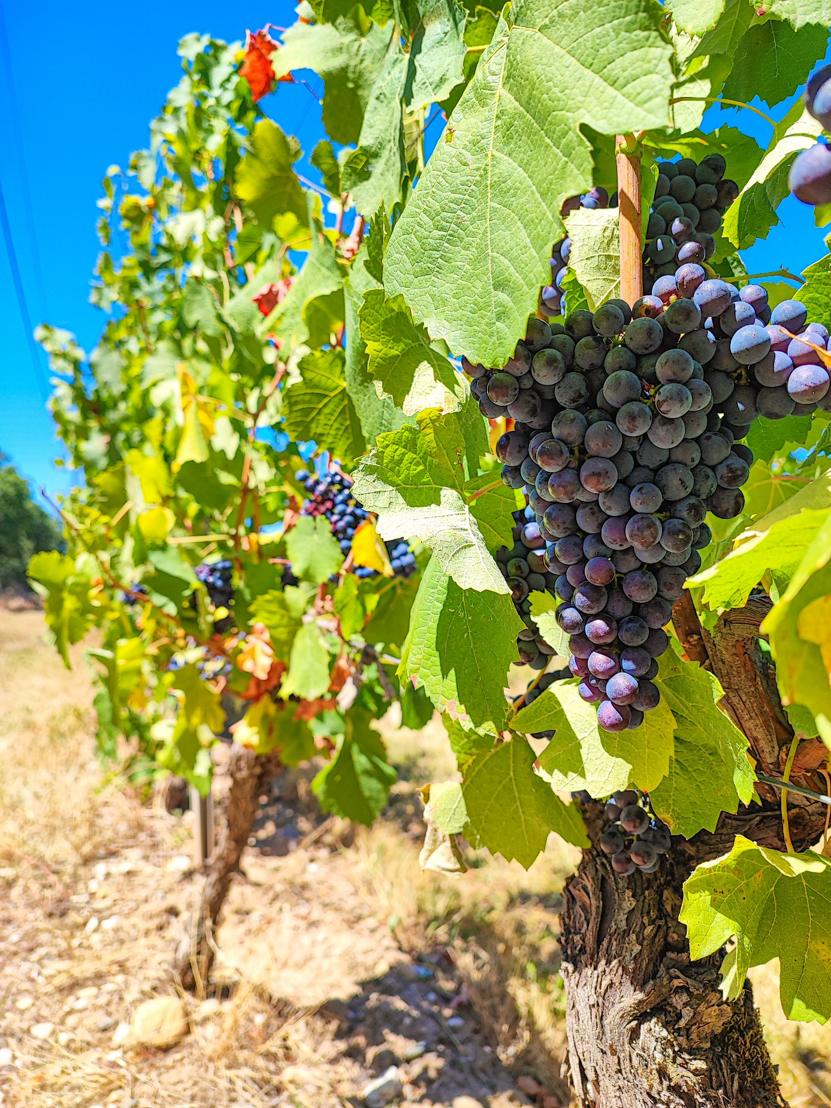

Autumn – The High Point

September: Harvest  
At last, the much-anticipated moment! Machine harvesting or hand-picking depending on the parcel and the cuvée, the harvest unites the entire team. The grapes, carefully sorted, are brought to the cellar, ready to become our finest wines. Night harvesting helps preserve freshness and the quality of the fruit.

October – November: Rest and Soil Enrichment  
After the celebrations of the harvest, the vine prepares for winter. Leaves fall, and the sap retreats to the roots. To nourish the soil, we apply natural, well-measured fertilizers — in harmony with nature — ensuring fertility and balance for the next season.

Planting – Renewal for the Estate

In autumn or spring, planting a young vine means shaping the future. The choice of rootstock, grape variety, and soil type — each decision helps create the great wines of tomorrow. At our estate, we take a long-term view, respecting tradition while embracing innovation.

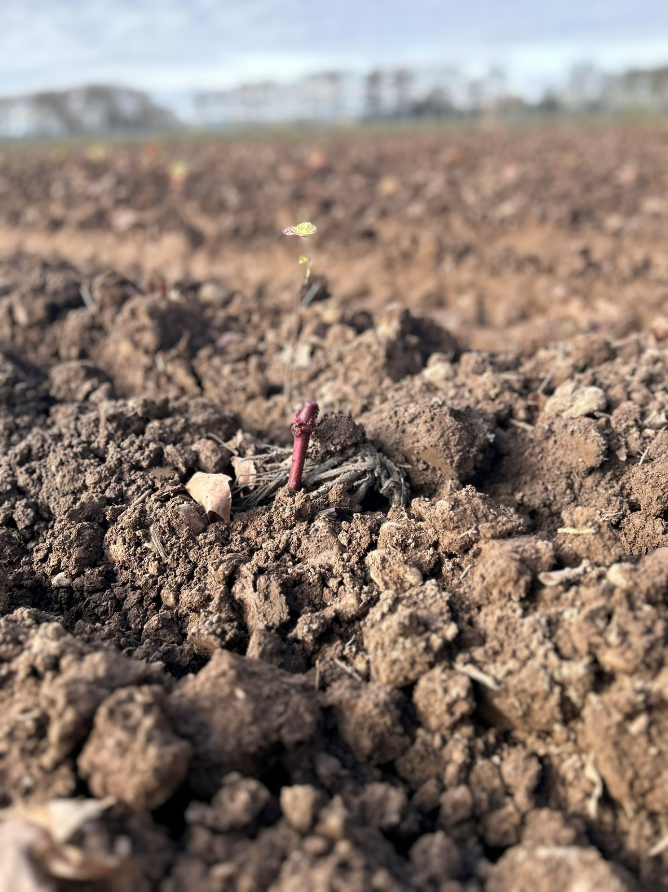

Climate and Adaptation – A Daily Commitment

Frost, drought, storms — climatic challenges are increasingly present. We invest in sustainable practices, adapt our methods, and anticipate risks to safeguard the richness and longevity of our vineyards.

Joining our team means sharing this passion for a job well done, the uncompromising pursuit of quality, and the joy of offering you authentic, unique, and sincere wines — true reflections of our terroir.

Our philosophy? Nature has its laws, and we have our passion. Discover the magic of vineyard work at the heart of our wine estate!

For more information, contact us or visit our domaine — experience the life of the vineyard at every stage of the year.